Still and Still Moving
Mayanka Mukherji

Michele de Certeau gives us a theory of the city without looking at it, but instead, by walking in it, exploring the natures of its constantly unraveling rhetoric. His theory is therefore an anthropological experience of the space, which gradually unravels specific practices or forms of operations, which transforms the stable, planned city into a migrational city or a city in a state of Walking Exile. However, these practices carry within them their own forgetfulness, as the process of walking cannot be localized, but only marked in city maps as that which has already passed, that which is no longer present. These practices therefore do not signify places, but in fact, invent spaces. He discusses two aspects of a city-space – the use or the elements of a code through which a system of communication manifests itself as a norm, and the style or the peculiar processing of the symbolic. He writes that the proper nouns or names of streets/places hierarchize and semantically order city surfaces to give a chronological arrangement and a historical justification. However, as one walks, these names signify beyond their first definition, thereby detaching themselves from places, turning into imaginary meeting points on fleeting itineraries. Through the extermination of proper nouns, the habitable city is thereby annulled, and what remains is a suspended symbolic order created though the simultaneous processes of displacement and condensation. This creates a fragmentation of memory itself, which de Certeau calls an anti-museum as we are crowded with memories of forgetfulness, presence of absences and visible identities of the invisible, through the processes of walking and the discourse of the encounter. The place is thus defined as an embodiment of these striated forms of memory, which are constantly created, erased and recreated. This brings to mind a fascinating graffiti project in London by a UK based street artist known as Mobstr (2014).
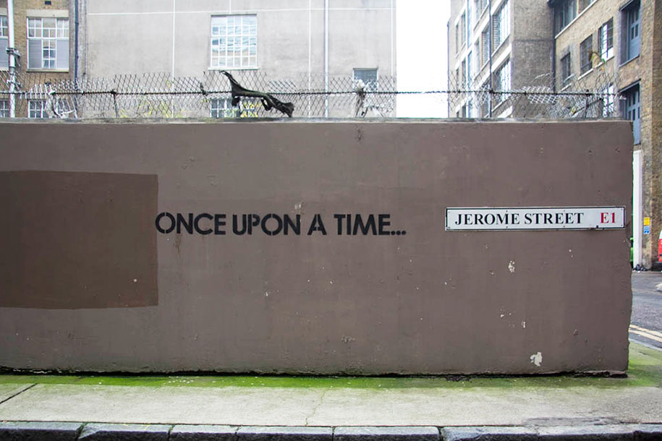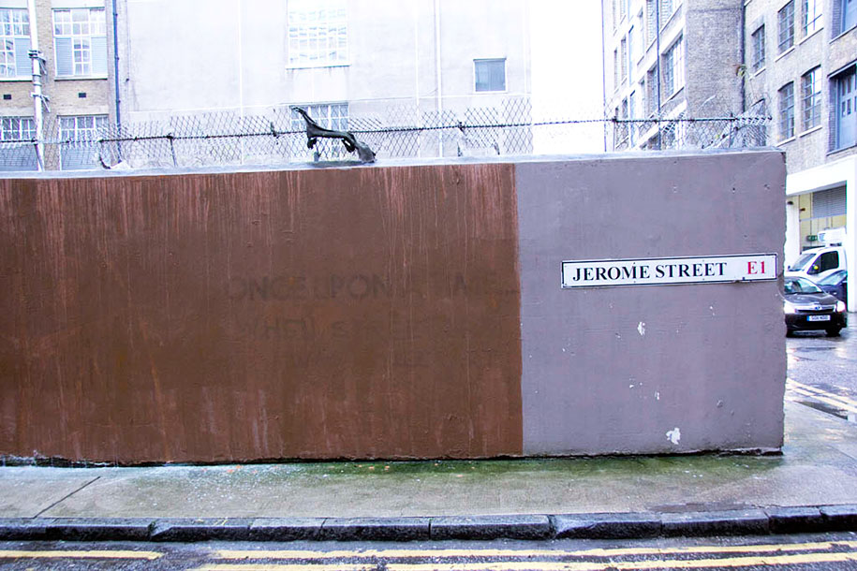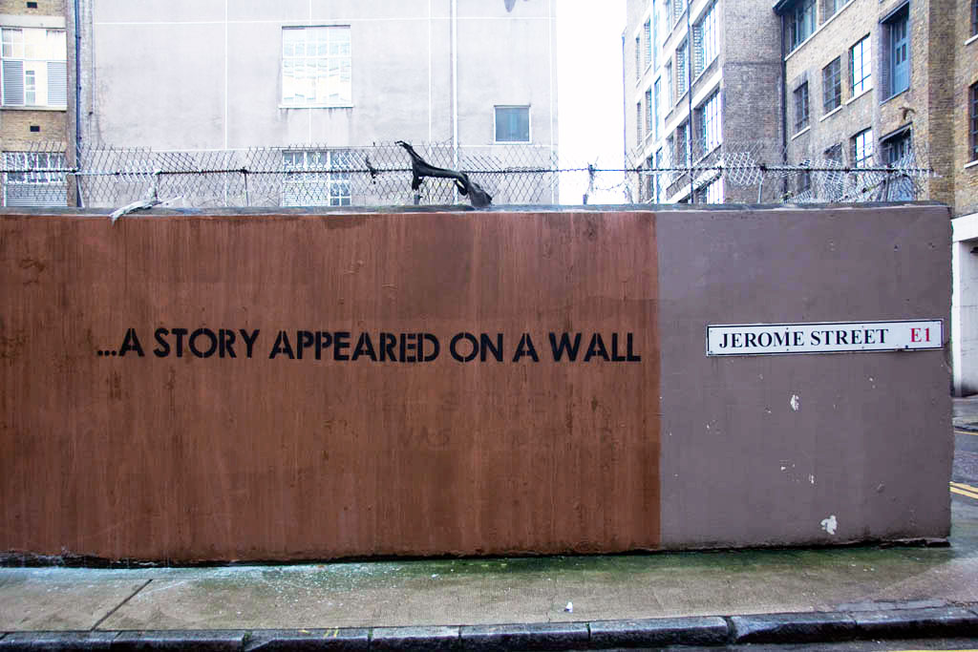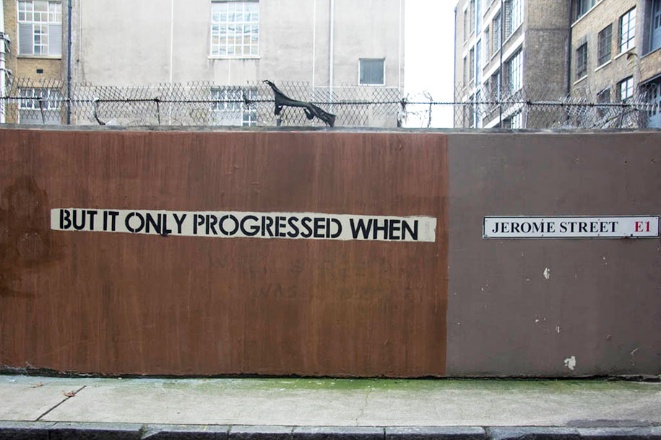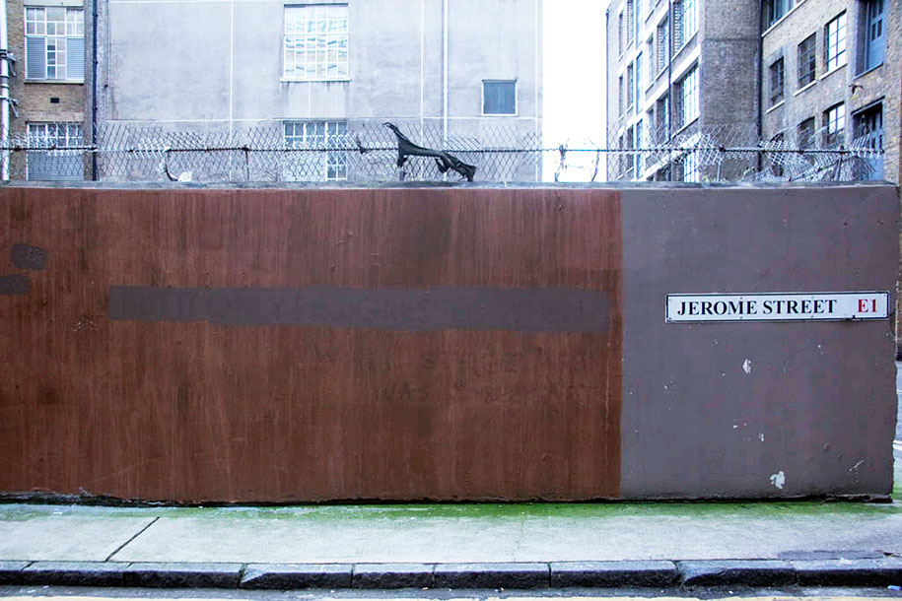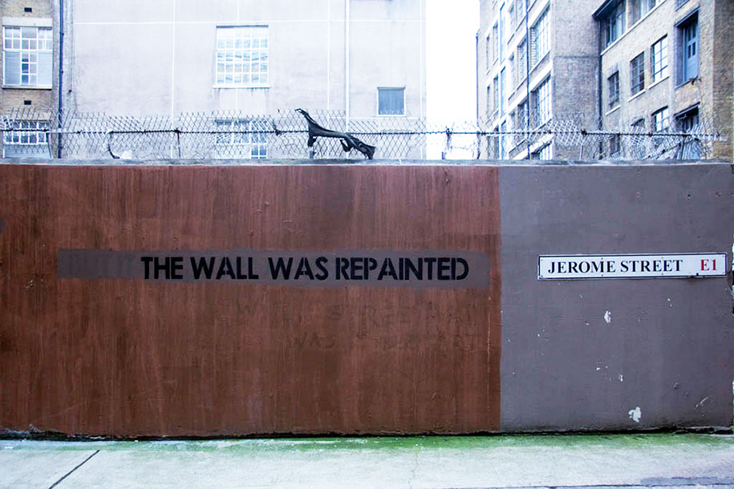
The graffiti project opens up a discussion on the idea of public space, while also visually illustrating the intertwining of memory and forgetfulness inscribed in places as discussed by de Certeau’s analysis of an encounter-based discourse.
Basso further describes place-making as a universal tool of the historical imagination. Ways of remembering a place are entangled with the ways of imagining it. He turns space into a verb, in an act, into a form of doing, thereby making the process of being in a place inseparable from being a place. Place-making thus becomes a form of narrative art or a type of historical theatre wherein the past is produced as the present unfolding before one’s eyes in the now and the here. The compressions of space and time is also explored by Schivelbusch, in his analysis of the subjective perception of space-time through the notion of duree or duration of travel brought about with the coming of the railways, which therefore turns space into a living entity. The in-between space is rendered unimportant, producing nothing but a useless spectacle, as the railroad space is built around the points of departure and points of destination. These points thus lose their sense of local entity, which was earlier provided by the spaces around them, and turn into isolated localities marked by their complacent individualities. I wonder if they can be said to constitute a place without space, or a space devoid of places? This loss of local sense of space was also followed by a loss of local time, as the local time of the starting point and the local point of the ending point of a journey were determined relative to each other, and not to the several points of time that was held daintily by the in-between spaces. He further adds that this experience of travel is equivalent to the experience of being dispersed, as the active traveller transforms into a passive parcel being moved, shifted, dislocated. This brings to mind the poem by T. S. Eliot, called East Coker;

Old men ought to be explorers
Here and there does not matter
We must be still and still moving
Into another intensity
For a further union, a deeper communion
Through the dark cold and empty desolation
The wave cry, the wind cry, the vast waters
Of the petrel and the porpoise.
In my end is my beginning.

The total emancipation from the traversed landscape was further heightened by the act of reading on the train, which is almost a custom as old as the railway itself, as we see the presence of book stalls on nearly every railway station. The contrast between the outside landscape and the insides of the train compartment creates a sense of being still and still moving, through the dissolution and the panoramization of the outside landscape into a framed view from the window.

While the above readings dealt with space by moving through it, either by walking in the case of de Certeau, or by sitting inside a train in the case of Schivelbusch, it is important to remember that moving, while appearing to dislocate and displace, is also the only way to locate and to place. The discourse of mobility therefore does not obliterate the relevance of location and place, but aims to understand these concepts through the physical experience of movement and stillness, and through the tangible nature of memorializing and forgetting. To occupy a place is therefore intertwined with the act of being occupied with a place, or rather, by a place. The sense of a space, or rather, as Basso puts it, the sensing of a space, is therefore a culturally constituted experience, which is fundamentally tied with the sense of being or a sense of identity.

